Software Requirement Specification Document
For

Suspicious Activity Tracker System

Table of Contents

1. Introduction
1.1 Purpose
1.2 Intended Customers/Users
1.3 Product Scope
1.4 Outline of the document

2.Overall Description
2.1 Product Perspective
2.2 Product Functions
2.3 User Classes
2.4 Design and Implementation Constraints

3.Diagrams
3.1 UML Diagrams
3.2 ER Diagrams
3.3 DFD Diagrams
3.4 Assumptions and Dependence

4.External Interface Requirements/Screenshots
4.1 User Interfaces
4.2 Hardware Interfaces
4.3 Software Interfaces
4.4 Communication Interfaces

5.Other Non-Functional Requirements
5.1 Performance Requirements
5.2 Safety Requirements
5.3 Security Requirements
5.4 Software Quality Attributes
5.5 Business Policies/Rules (if any)

6.Testing
6.1 Block-Box Testing
6.2 White-Box Testing
7.Conclusion
8.References
9.Acknowledgement

1.Introduction
  - Purpose
- The main purpose of this project is to design and develop Suspicious Activity Tracker. This software helps to continuously monitor and record user activities with in a system.
- This system aims to reduce the dependency on manual monitoring by automatically tracking activities and identifying behaviour that does not match normal usage patterns.
- It helps administrators become aware of possible security issues at an early stage.
- This document helps in explaining the objectives, features, scope, and limitations of the system so that anyone reading it can understand the idea of this project.

  - Intended Customers / Users
- The primary users of this system are system administrators who are responsible for managing users and monitoring activities. They use the system to view alerts and reports, and logs related to suspicious actions.
- Security staff can also use this system to observe unusual activity patterns and analyse stored data logs for investigation purposes.
- Organization such as colleges, offices, and companies can use this software for more security purposes and keep track of system usage.
- General users will interact with system only for normal operations such as login and access, and they don’t have permission to view the security details or monitor.
- Product Scope
- The Suspicious Activity Tracker system mainly focuses on recording user activities such as login attempts, logout actions, and access behaviour. all these activities are securely stored for analysis and for the references.
- This system compares current user pattern with normal usage pattern to identify suspicious actions.when such activities are detected, alerts are sent and inform administrators for furtherreview and take a suitable actions.
- Future improvements can include using advanced technology or AI based detection on requirements.
- Outline of the Document
- This document start with an introduction that explains a purpose of this document.
- This document also explains importance of this software system.
- The next section explains overall behaviour of system, including user and main functions.
- Further sections explains diagrams, interface requirements and non-functional requirements.
- At the end document ends with testing details, conclusion, references and acknowledgment.

2.Overall Description
  - Product Perspective
- The Suspicious Activity Tracker is developed as a independent software.
- It is ready to linkup with current software or networks.
- The system depends on user activity data for analysis.
- This system runs in background and does not disturb normal user operations.
- Product Functions
- The system monitor user login and logout activities along with access attempts.
- Based on predefined rules, the system analyse collected data to identify suspicious behaviour.
- Alerts are generated when abnormal activities are detected.
- Simple reports are provided that help security staff can review past activities.
- user classes and Characteristics:
  Administrator
- Has full accessto the system and manages users, permissions, and alerts.
- Review reports and takes decisions based on system notifications.
- Security staff
- Monitors alert and review activity logs and suspicious behaviour is reported.
- They help in identifying patterns and supporting investigations.
- General User
- Uses the system normally with limited permissions.
- Has no access to monitoring or administrative features.
  - Design and Implementation Constraints
- Proper activity data is required for correct system results.
- Internet or network stability is important for system operations,
- User information is protected by following privacy rules.
- The project is developed as part of academic course work.
- The system is built with a limited resources.
- It is supports normal operating systems.
3.UML Diagrams
- Module 1 : “User Authentication Module”
    - Description: This User Authentication Module handles user login, logout, and password management. It ensures that only authorized users can access the system.
- Primary Actors :User

- Secondary Actors: 1. Administrator
2. Security Staff
3. General User
- Use Case Diagram:
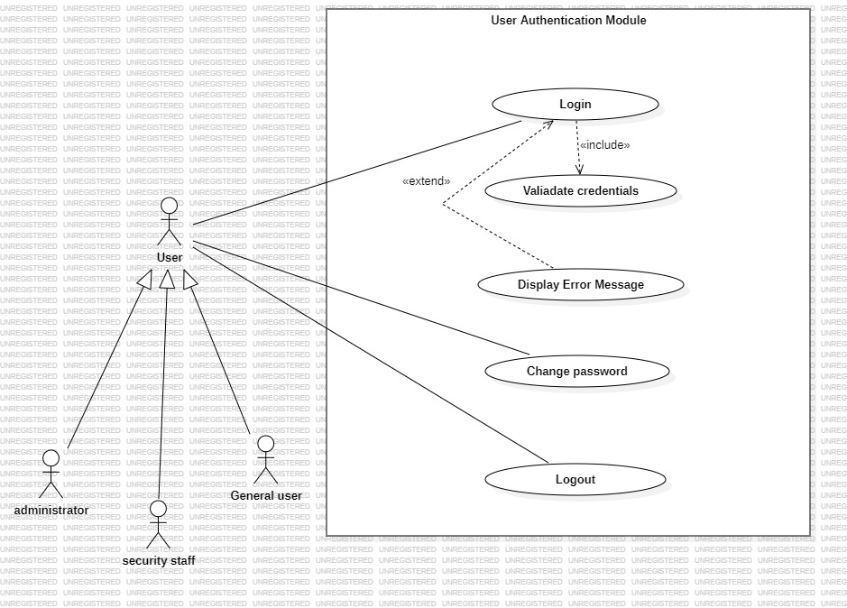
3.1.1 use case diagram - User Authentication

- Module 2: “Activity Monitoring”
- Description:
This module continuously monitors and records user activities such as login attempts and access behaviour. All monitored activities are logged and stored securely. Administrators can view activity logs for monitoring and analysis purpose.
- Primary actors: System
- Secondary actors: 1. User
2. Administrators
- Use Case Diagram: 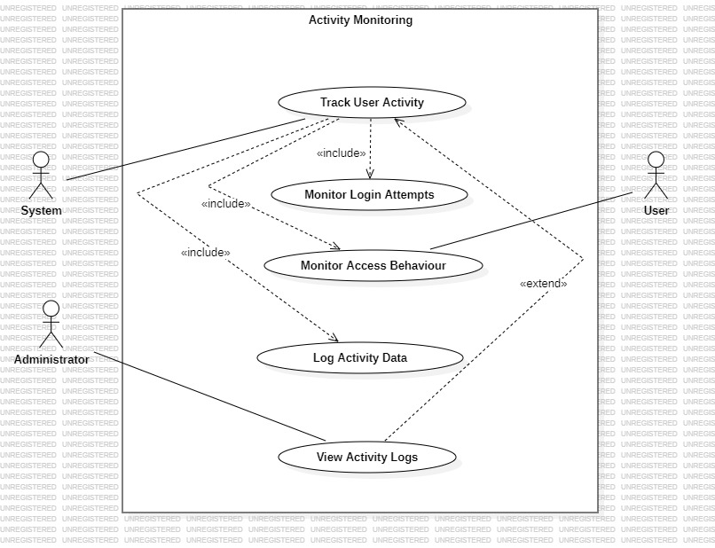
3.1.2 Use Case Diagram - Activity Monitoring

- Module 3: “Suspicious Activity Detection”
- Description: This diagram shows the functioning of the suspicious Activity Detection Module. The System checks the monitored activity data and compares it with predefined rules to find suspicious behaviour. The detected activities are classified, and reports are generated whenever required. Administrators and security staff review these results for security monitoring and further action.
- Primary Actor :User
- Secondary Actors: 1. Administrator
2. Security staff
- Use Case Diagram:
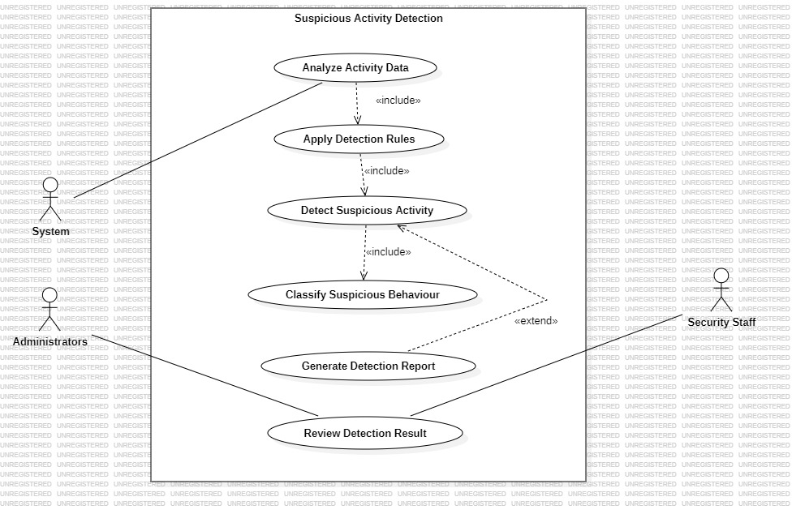
    - Use Case Diagram – Suspicious Activity Tracker
- Module 4 : “Alert Management Module”
- Description :This module is used to handle alerts generated when suspicious detected in the system. Whenever an abnormal activity is found, the system creates an alert and sends it to the concerned users. Administrators and security staff can view these alerts and take necessary actions based on the alert. This module helps in responding quickly to security-related issues and improves overall system safety.
- Primary Actors : 1.Administrators
2.Security staff
- Secondary Actors :1.System
2.Notification Service
- Use Case Diagram:
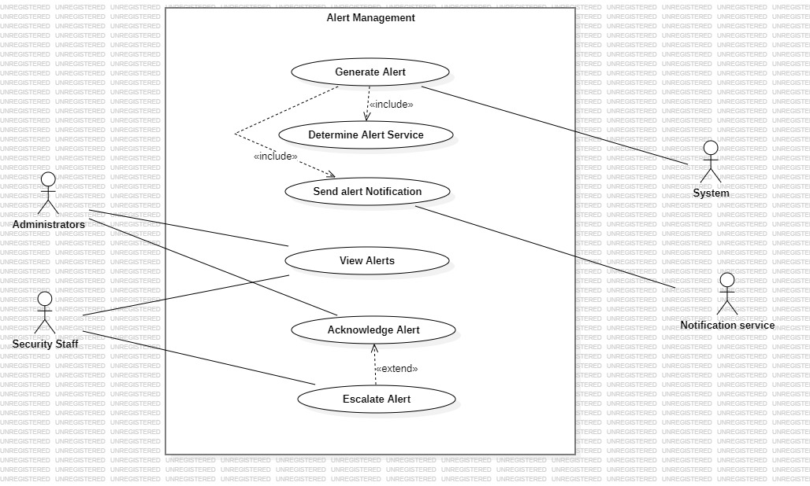
3.1.4 Use Case Diagram – Alert Management

- Module 5: “Report Generation”
- Description: This module is used to generate reports based on the activities monitored and suspicious events detected in the system. the system prepares reports such as daily activity reports. Administrators and Security staff can view and download these reports for analysis and record purposes. This module helps in understanding system behaviour and supports decision making.
- Primary Actors : 1.Administrator
2.Security staff
- Secondary Actors :System
- Use case Diagram :
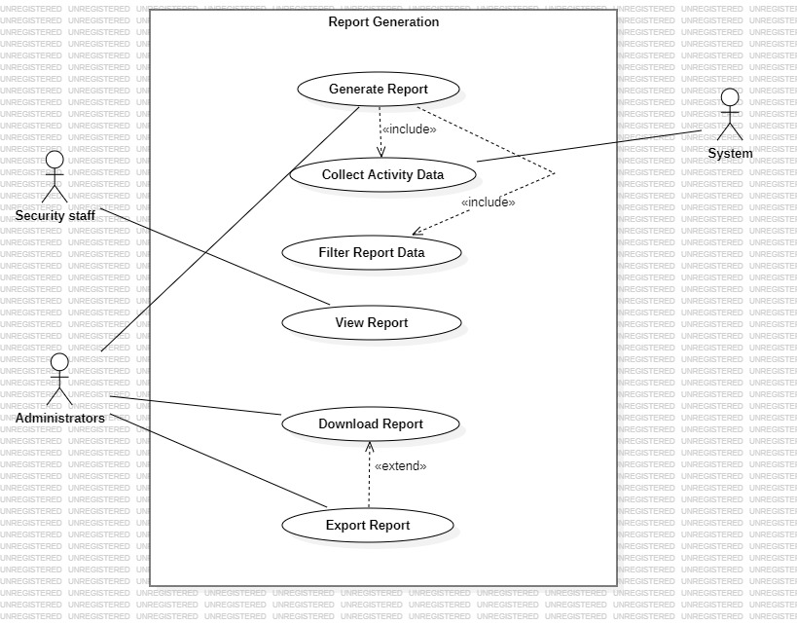
3.1.5 use case diagram – Report Generation

- Module 6: “ User& System Management”
- Description :This module is used to manage users and system-related setting in the Suspicious Activity Tracker-System. The administrator can add new users, update user details , assign roles, and remove users when required. This module also allows managing system configurations and viewing system logs. By controlling users and system settings, this module ensures proper access and smooth functioning of the system.
- Primary Actors :Administrator
- Secondary Actors :1.System
2.Security staff
- Use Case Diagram :
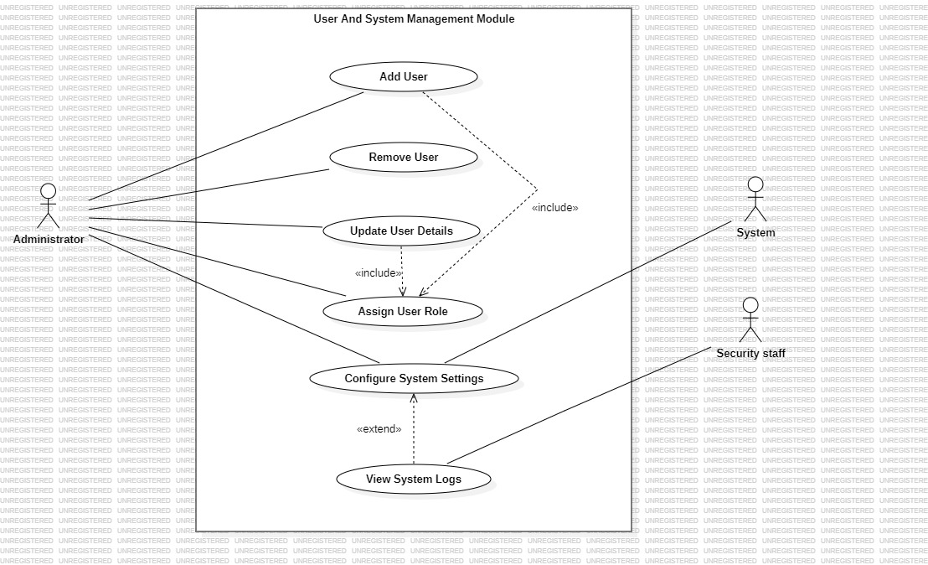
3.1.6 : use case diagram – User & System Management

3.2 Class Realtionships
- Module 1: User Authentication
- Module Description :This module handles user login, logout, and authentication process.it ensures that only authorized users can access the system and maintains sessions information securely.
- Classes : 1.User
2.Admin
3.AuthenticationService
4.Session
- Class Diagram: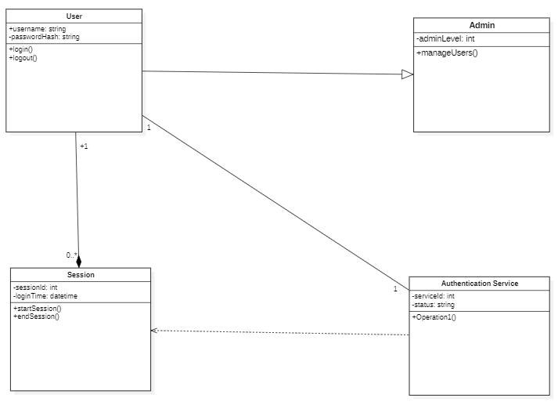

- Module 2 : Activity Monitoring
- Module Description :this module continuously monitoring user activities within the system.it records actions Performed by users and stores them for further analysis.
- Classes :1.UserActivity
2.ActivityMonitor
3.ActivityLog
4.SystemResource
- Class Diagram :
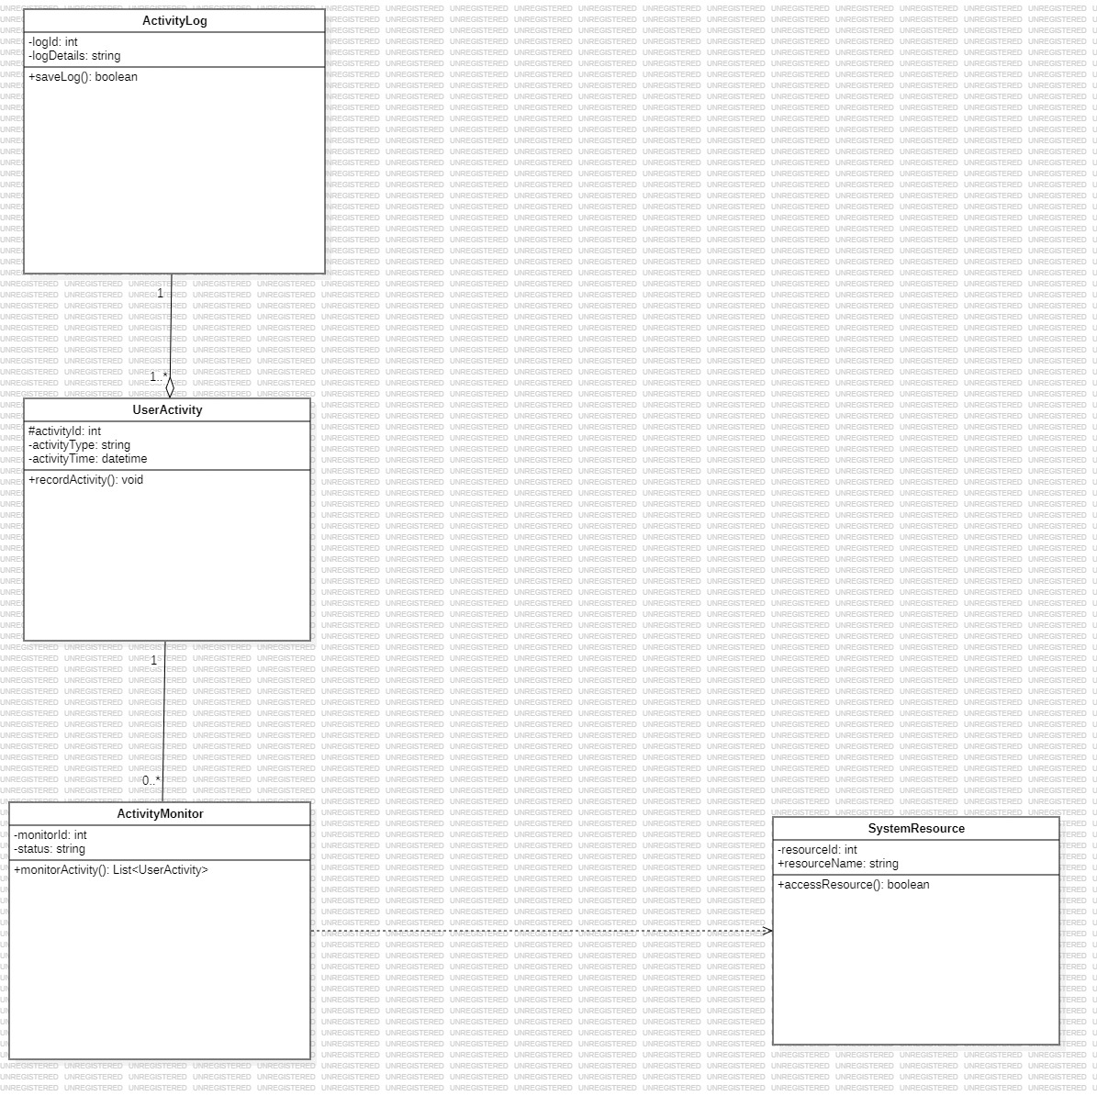

- Module 3:Suspicious Activity Detection

- Module Description :this module analyses monitored activity data to detect suspicious behaviour.it applies predefined rules and generates detection results.
- Classes :1.DetectionEngine
2.ActivityData
3.DetectionRule
4.DetectionResult
- Class Diagram:
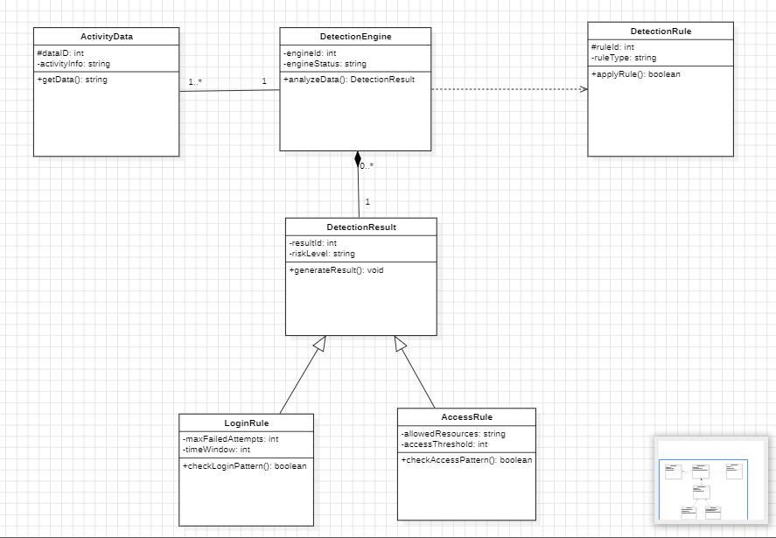

- Module 4: Alert Management

- Model description :this module generates alerts when suspicious activities are detected.it notifies users or administrators based on alert severity.
- Class :1.AlertManager
2.Alert
3.Notification
4.user
- Class Diagram :
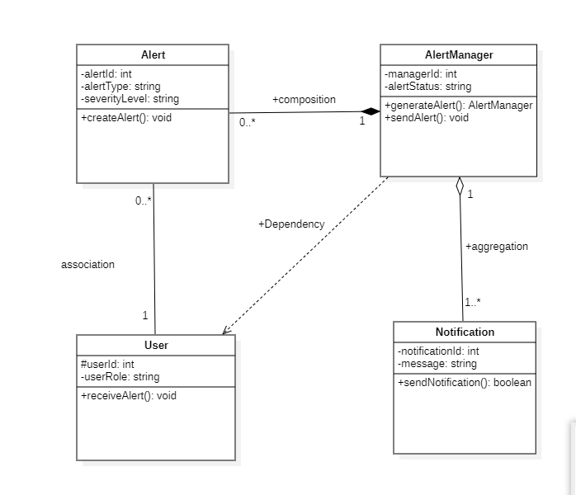
- Module 5 : Report Generation
- Module Description: this module generates system reports using stored activity logs.Reports help administrators review system behaviour and security events.
- Classes: 1.ReportManager
2.report
3.ActivityLog
4.Admin
- Class Diagarm :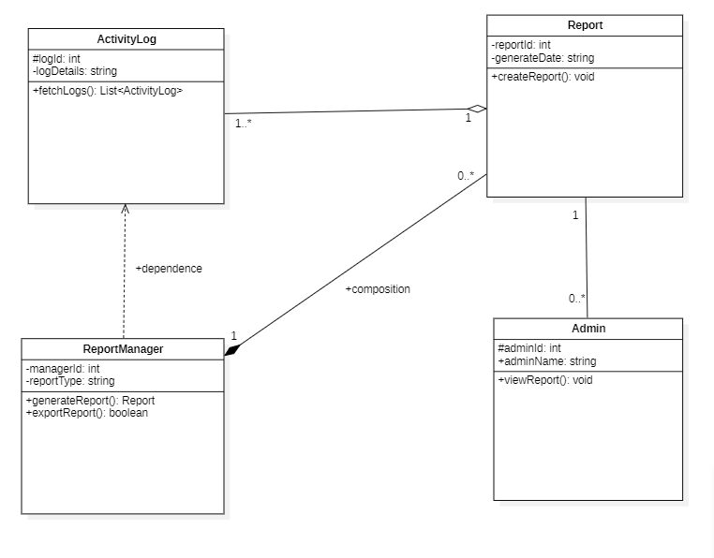

- Module 6 :User & System Management

- Module Description :this module manages system users and configuration settings.it allows administrators to control user accounts and system behaviour.
- Classes : 1.User
2.Admin
3.systemManager
4.SystemSettings
- Class Diagram :

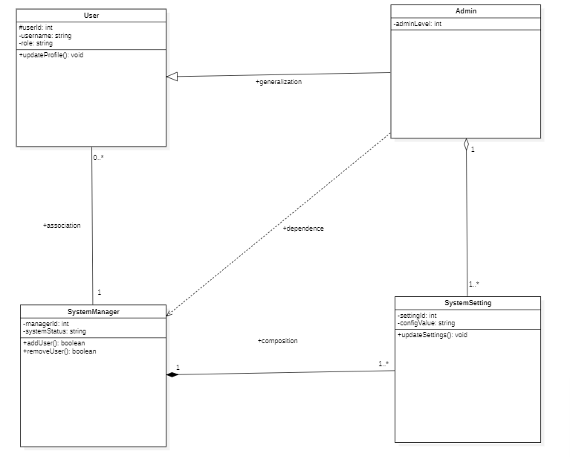

3.4State Chart Diagrams

- Module-4:

- Alert Manager :
The AlertManager state chart diagram explain how alerts are handeled in the system.it shows the steps from alert creation to classification and management based on suspicious activities.the diagram also includes decision making and parallel actions like spending notifications and logging details before the process ends.
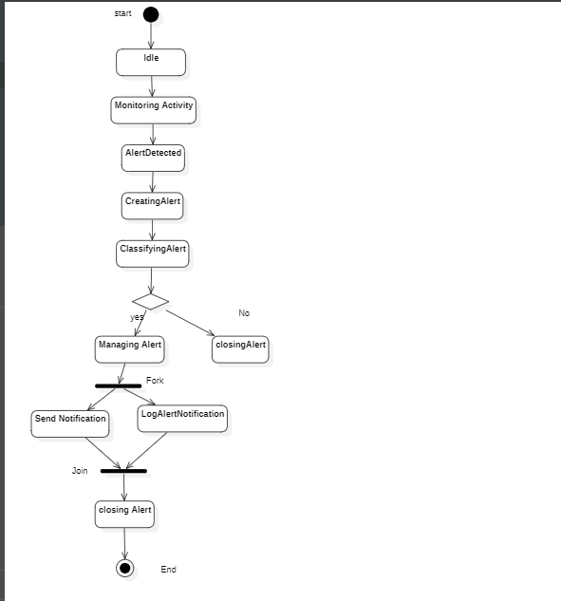
- Alert:

This state chart diagram explains how an alert is created,validated,classified and either activated or resolved.

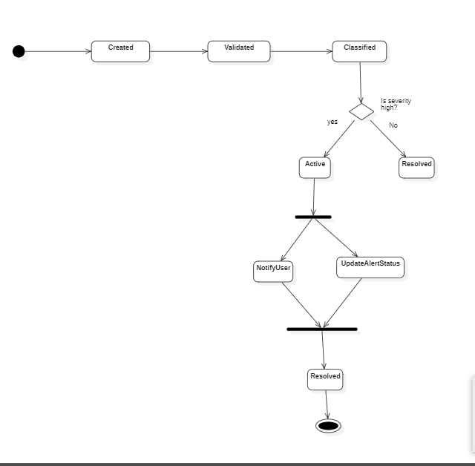

- Notification :
This statechart diagram describes the notification process from completion.it shows how notifications are queued,sent,delivered and logged.
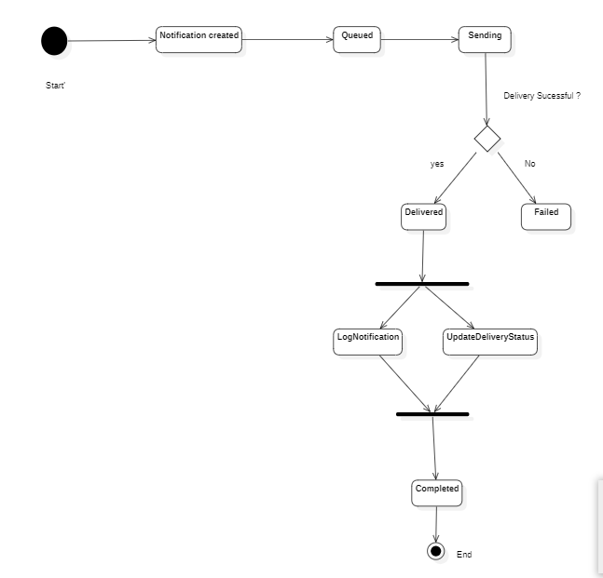
- User :
This statechart diagram represents the behaviour of security staff while handling alerts.it shows how alerts are reviewed,decisions are made ,andactionsare performed.
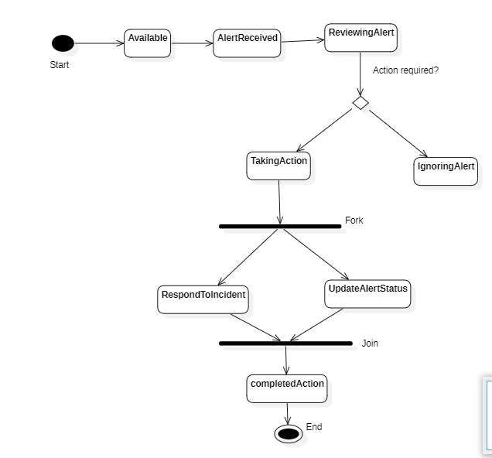

3.5Activity Diagrams
This Activity Diagram illustrates the workflow of detecting
suspicious activities by analysing monitored data and applying detection rules.
- Suspicious Activity Module :
The Suspicious Activity module monitors user activities and analyzes the collected data to detect unusal or suspicious behaviour.when suspicious activity is identified,the result is sent to the alert managenment module for further action.
  - Alert Management :
The alert management module processes alerts generated by the system and assigns priority to each alert.it also sends notifications to the concerned users and updates the alert status.

  - Suspicious Activity Module :
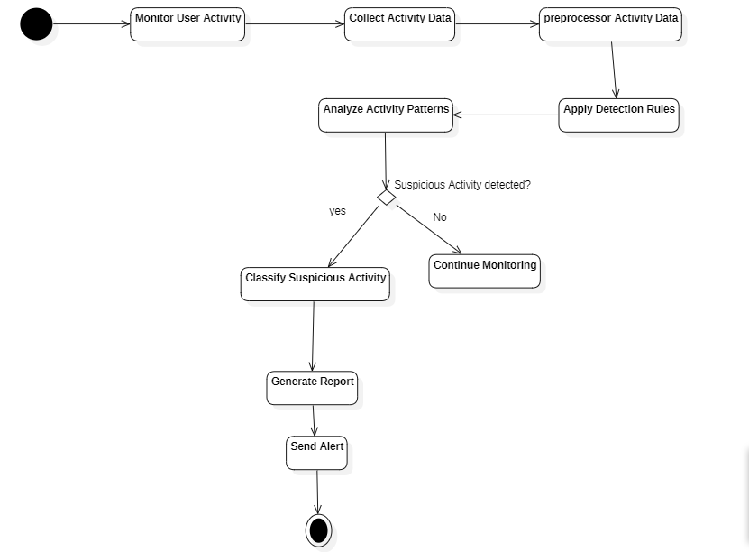
- Alert Management :
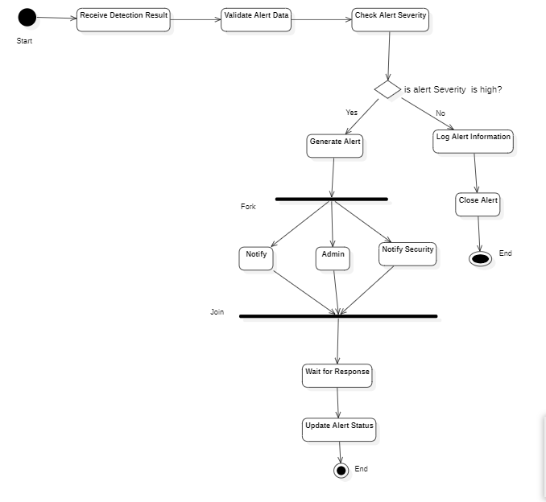
3.6 Sequence Diagram
- Module4 : Alert Management
This sequence diagram shows how a suspicious activity is reported by the security staff and handeled by the alert Manager.it explains how an alert is created ,processesed,and finally a notification is sent before the alert lifecycle is completed.
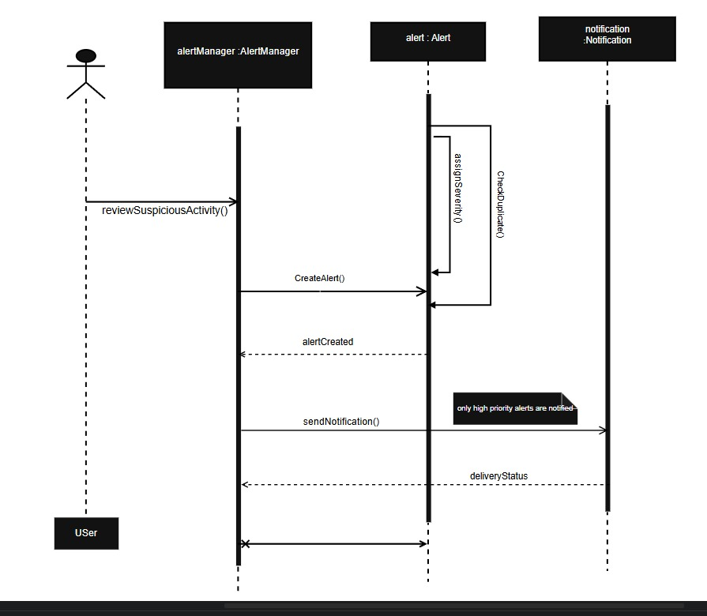

- User Authentication-Admin Login
This sequence diagram explains how the admin logs into system,how the credentials are verified by the authentication service,how a session is created,and how the login result is returned to the admin.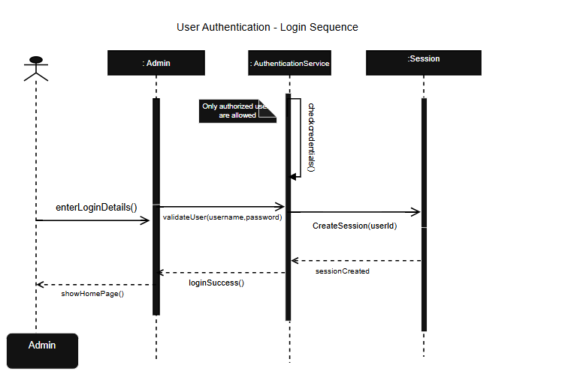
- Activity Monitoring :
This sequence diagram briefly explains how user activities are captured,analysed by the monitoring component,stored in the activity log,and how the activity recording process is completed by the system.
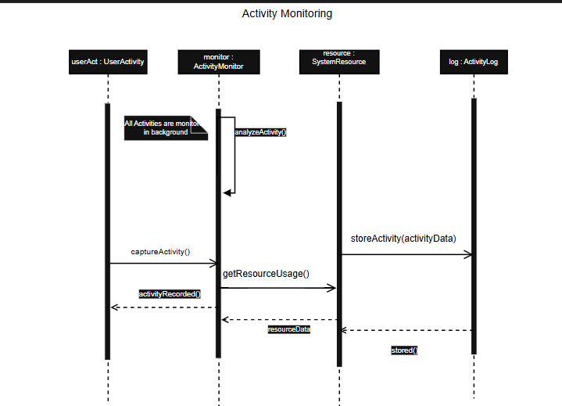

3.7 Collaboration Diagram
- User Authentication :

This collaboration diagram shows how the admin,Authenticationservice and Session objects interact to perform the login process.

It explain how the admin sends a login request,how the authentication service validates the credentials,creates a session and returns the login status to the admin.

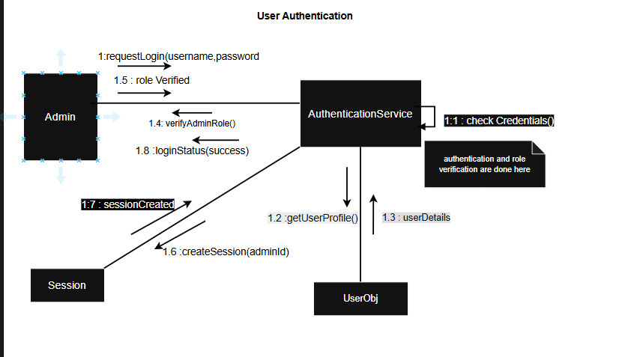
- Report generation :
This collaboration diagram shows how the Admin, ReportManager, ActivityLog and report objects coordinate to generate system reports.
It explains how the report request is processesed,activity logs are collected,the report is generated and finally delievered to the admin.
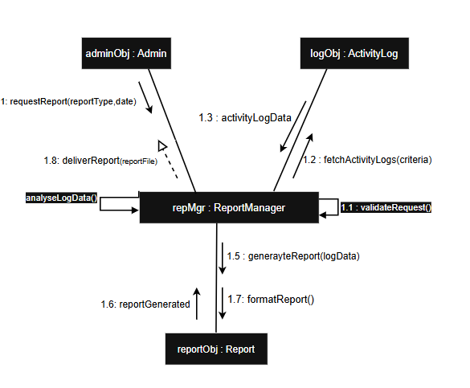

- User & System Management :
This collaboration diagram shows how the admin interacts with the SystemManager to manage user and system settings.the system manager validates user details,creates user accounts,assigns roles and update system configuration by communicating with the user and systemSettings objects.it explains thecoordination between objects for user management and system configuration opearations in the system.
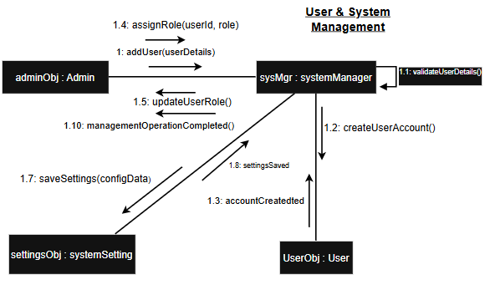
3.8Data Flow Diagram

- Level -1 Data flow Diagram
The Level-1 Data flow diagram of the Suspicious Activity Tracker System shows how user data and activity information are processed through five main modules.
- The User Authentication moduke verifies login details using the user database and provides access status to administrators.
- The Activity Monitoring module collects user activities and stores them in the activity log.
- The suspicious Activity detection module analyses current and past activities to identify abnormal behaviour.
- The Alert management module sends alert notification to administrators and security staff and stores alert information.
- The report generation module produces reports using activity and alert data and delievers the reports to authorized users.
Level -1 Data flow Diagram:
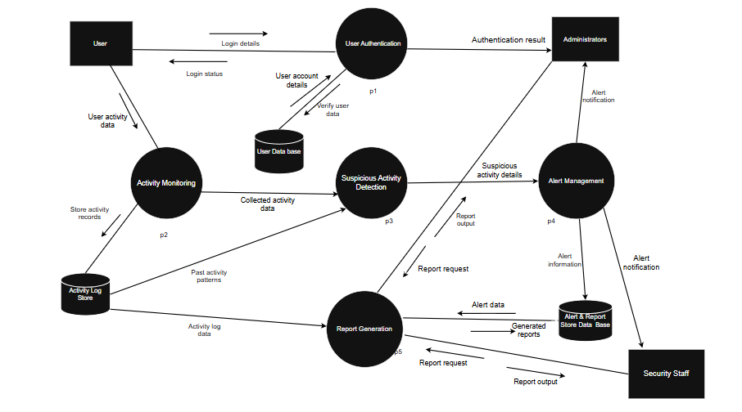

3.9 ER Diagram
- Description :
- The ER Diagram shows how user data,activities,and alerts are related in the suspicious Activity tracker System.
- A user can perform many activities, and each activity belongs to a single user.
- Every activity can generate multiple alerts, and each alerts is linked to one specific activity.
This structure clearly explains how user actions are stored and how suspicious events are tracked through alerts in the system.
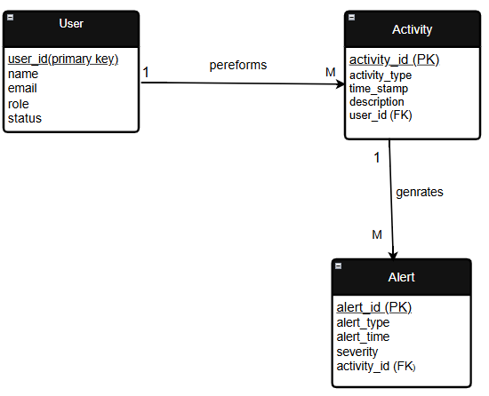

4.External Interface Requirements

- 4.1 User Interfaces:
The suspicious activity tracker System provides different user interfaces based on the role of the user.
- User Interface :
The User interface allows to users to log in to the system,
perform activities and view their own activity history.
- Administrator Interface :
The administrator interface allows administrators to monitor user activities,view suspicious activity alerts,generate reports and manage system users.
- Security Staff Interface :
The security staff interface allows security personnel to receive alert notifications,view alert details and check reports related to suspicious activities.

- 4.2 Hardware Interfaces :

The suspicious activity tracker system mainly works as a software based system and doesnot require special hardware to opearate.
The system runs on standard computer system and serves.

- 4.3 Software Interfaces :
The suspicious activity tracker system interacts with the following software interacts with the following software component.
- Operating System :
The system can run on common opearating system such as window or Linux.
- Database System :
The System uses a database to store user information,activity logs and alert data
Example : MySQL or MongoDb
- External APIs :
The system can integrate with external monitoring or security APIs to collect activity data when required.
1.Notification API
When a suspicious activity is detected,the system can send instant alerts.
2.Email Alert API
To deliver alert notifications and generated reports through email.
3.IP & Location Intellience API
to analyseuser access location and detect abnormal or suspicious login locations.
4.Threat/Malware/Suspicious Indicator API
To verify whether an IP or link involved in activity is already known as malicious.
- Web browser :
A web browser is required for users,administrators and security staff to access the system.
- Application Server
The system requires a backend runtime to execute business logic such as activity analysis,alert generation and report creation.

5.OTHER NON-FUNCTIONAL REQUIREMENTS
- 5.1 Performance Requirements :
- The system shall respond to user actions such as login,alert viewing and report requests within an acceptable time.
- The system shall handle multiple users accessing the system at the same time without performance degradation.
- The system shall support continuous monitoring of user activities without delay.
- The system shall generate reports within a reasonable time even when a large activity data is processed.
- 5.2 Safety Requirements:
- The system shall maintain regular backups of user data,activity logs and alert information.
- The systemshall provides data recovery support in case of system failure.
- The system shall prevent data loss during unexpected shutdowns.
- The system shall handle system errors and failures safely and display appropriate error message to users.
- 5.3 Security Requirements :
- Only authenticated users shall be allowed to access the system.
- Role based access controlshall be applied for users,administrators and security staff.
- Sensitive data such a login credentials and alert information shall be protected.
- The system shall prevent unauthorized access to logs and reports.
- 5.4 Software Quality Attributes :
- The system shall be reliable and should opearate continuously for activity monitoring.
- The system shall be easy to use for administrators and security staff.
- The system shall support future expansion such as adding new monitoring source.
- The system shall be easy to maintain and update without affecting existing functionalities.
- 5.5 Business Policies/Rules :
- No specific business rules are applicable for this project.

6.Testing
Suspicious Activity Detection:
Sample code :
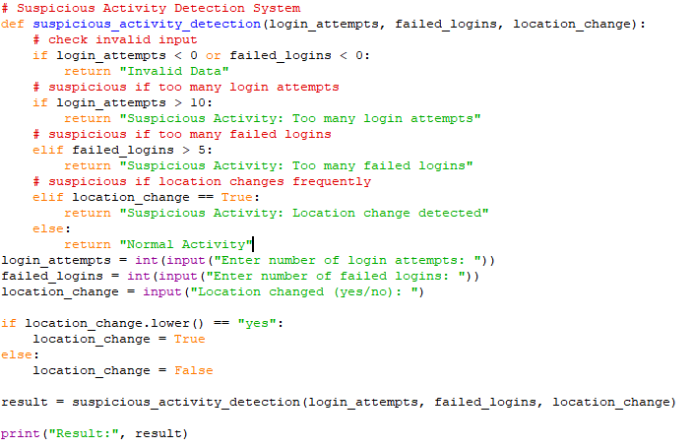
White Boxing Testing :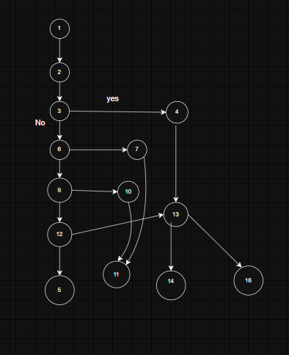

2. Cyclomatic Complexity:
Method 1:
Inner region =4
Outer region=1
Total regions=5
V(G)=5
Method 2:
V(G)=E-N+2
E=Number of edges
N=Number of nodes
From the flowchart:
Edges(E)=15
Nodes=14
V(G)=15-14+2
V(G)=3
Method 3:
V(G)=P+1
Where P=number of decision nodes
Decision nodes :
Node 3,6,9,12
P=4
V(G)=4+1
V(G)=5
This means the program has 5 independent execution paths.
Independent Paths :
Path 1: Invalid input data
1,2,3,4,16
Path2: Suspicious Activity-Too Many Login Attempts
1,2,3,6,7,16
Path3: Suspicious Activity – Too Many Failed Logins
1,2,3,6,9,10,16
Path4 : Suspicious Activity-Location Change detected
1,2,3,6,9,12,13,16

Path 5:Normal Activity
1,2,3,6,9,12,15,16
Path No | Independent path | Test Input | Expected Output
P1 | 1,2,3,4,16 | (-1,2,False) | Invalid data
P2 | 1,2,3,6,7,16 | (12,2,false) | Suspicious Activity: Too Many Login Attempts
P3 | 1,2,3,6,9,10,16 | (5,6,false) | Suspicious Activity – Too Many Failed Logins
P4 | 1,2,3,6,9,12,13,16 | (5,2,true) | Suspicious Activity-Location Change detected
P5 | 1,2,3,6,9,12,15,16 | (5,2,False) | Normal Activity
- Python unit test :
import unittest
# Function under test
defsuspicious_activity_detection(login_attempts, failed_logins, location_change):
# check invalid input
if login_attempts< 0 or failed_logins< 0:
return "Invalid Data"
# suspicious if too many login attempts
if login_attempts> 10:
return "Suspicious Activity: Too many login attempts"
# suspicious if too many failed logins
eliffailed_logins> 5:
return "Suspicious Activity: Too many failed logins"
# suspicious if location changes frequently
eliflocation_change == True:
return "Suspicious Activity: Location change detected"
else:
return "Normal Activity"

# Unit Test Class
class TestSuspiciousActivityDetection(unittest.TestCase):
# P1: Invalid Data
deftest_invalid_data(self):
self.assertEqual(
suspicious_activity_detection(-1, 2, False),
"Invalid Data"
)
# P2: Too many login attempts
deftest_too_many_login_attempts(self):
self.assertEqual(
suspicious_activity_detection(12, 2, False),
"Suspicious Activity: Too many login attempts"
)

# P3: Too many failed logins
deftest_too_many_failed_logins(self):
self.assertEqual(
suspicious_activity_detection(5, 6, False),
"Suspicious Activity: Too many failed logins"
)
# P4: Location change detected
deftest_location_change(self):
self.assertEqual(
suspicious_activity_detection(5, 2, True),
"Suspicious Activity: Location change detected"
)
# P5: Normal Activity
deftest_normal_activity(self):
self.assertEqual(
suspicious_activity_detection(5, 2, False),
"Normal Activity"
)

# Run the tests
if __name__ == "__main__":
unittest.main()
Output :
Ran 5 tests in 0.071s
OK
Black Box Testing
Step 1:Write functional Requirement
Login_attempts and failed_logins must not be negative .
If any value is negative –return “Invalid data”.
If login_attempts>10 –return “Suspicious Activity :Too many login attempts.”
If failed_logins>5-return “suspicious activity : too many failed logins”
If location_changed==True – return “Suspicious Activity :Location change detected”
OtherWise – return “Normal Activity”
Step2:Apply Black – Box Techniques
- Equivalence partitioning
- Boundary value Analysis
1.Equivalence partitioning
For login_attempts:
Class | Range | Valid/invalid
Ec1 | <0 | invalid
Ec2 | 0-10 | Valid
Ec3 | >10 | Suspicious
For failed_logins
Class | Value | result
Ec7 | True | Supicious
Ec8 | False | Normal
Black Box Test cases(Equivalence Partitioning)
BB No | Test Inputs | Expected Output | Techniques
Bb1 | (-1,2,False) | Invalid data | Ec1
BB2 | (5,-1,False) | Invalid data | Ec4
BB3 | (11,2,False) | "Suspicious Activity: Too many login attempts" | Ec3
BB4 | (5,6,false) | “suspicious activity : too many failed logins” | Ec6
BB5 | (5,2,True) | “Suspicious Activity :Locationchange detected” | Ec7
BB6 | (5,2,False) | Normal Activity | Ec8
2.Boundary Value Analysis
Login Attempts Boundary
BB No | Test Input | Expected Output | Technique
BB7 | (-1,2,false) | Invalid data | Below 0
BB8 | (0,2,false) | Normal Activity | Boundary 0
BB9 | (1,2,false) | Normal Activity | Above 0
BB10 | (10,2,False) | Normal Activity | Boundary 10
BB11 | (11,2,false) | Suspicious Activity: Too many login attempts | Above 10

Failed Login Boundary(0 and 5)
BB No | Test Input | Expected Output | Technique
BB12 | (5,-1,false) | Invalid data | Below 0
BB13 | (5,0,false) | Normal Activity | Boundary 0
BB14 | (5,1,false) | Normal Activity | Above 0
BB15 | (5,5,false) | Normal Activity | Boundary 5
BB16 | (5,6,false) | Suspicious Activity :too many failed logins | Above 5
3) Black-box testing does NOT end with creating tables.
# Suspicious Activity Detection Function
defsuspicious_activity_detection(login_attempts, failed_logins, location_change)
if login_attempts< 0 or failed_logins< 0:
return "Invalid Data"

if login_attempts> 10:
return "Suspicious Activity: Too many login attempts"

eliffailed_logins> 5:
return "Suspicious Activity: Too many failed logins"

eliflocation_change == True:
return "Suspicious Activity: Location change detected"

else:
return "Normal Activity"

# Black Box Test Cases
test_cases = [
# (login_attempts, failed_logins, location_change, expected_output)
(-1, 2, False, "Invalid Data"), # BB1
(5, -1, False, "Invalid Data"), # BB2
(11, 2, False, "Suspicious Activity: Too many login attempts"), #BB3
(5, 6, False, "Suspicious Activity: Too many failed logins"), # BB4
(5, 2, True, "Suspicious Activity: Location change detected"), # BB5
(5, 2, False, "Normal Activity"), # BB6
(0, 0, False, "Normal Activity"), # BB7
(10, 5, False, "Normal Activity"), # BB8
(10, 6, False, "Suspicious Activity: Too many failed logins"), # BB9
(11, 5, False, "Suspicious Activity: Too many login attempts") # BB10
]

# Execute Black Box Tests
print("Running Black Box Test Cases\n")

for i, test in enumerate(test_cases, start=1):
login_attempts, failed_logins, location_change, expected = test
result = suspicious_activity_detection(login_attempts, failed_logins, location_change)

if result == expected:
status = "PASS"
else:
status = "FAIL"

print(f"BB{i}: Input=({login_attempts}, {failed_logins}, {location_change})")
print(f"Expected: {expected}")
print(f"Actual: {result}")
print(f"Result: {status}\n")

Output :
Running Black Box Test Cases
BB1: Input=(-1, 2, False)
Expected: Invalid Data
Actual: Invalid Data
Result: PASS
BB2: Input=(5, -1, False)
Expected: Invalid Data
Actual: Invalid Data
Result: PASS
BB3: Input=(11, 2, False)
Expected: Suspicious Activity: Too many login attempts
Actual: Suspicious Activity: Too many login attempts
Result: PASS
BB4: Input=(5, 6, False)
Expected: Suspicious Activity: Too many failed logins
Actual: Suspicious Activity: Too many failed logins
Result: PASS
BB5: Input=(5, 2, True)
Expected: Suspicious Activity: Location change detected
Actual: Suspicious Activity: Location change detected
Result: PASS
BB6: Input=(5, 2, False)
Expected: Normal Activity
Actual: Normal Activity
Result: PASS
BB7: Input=(0, 0, False)
Expected: Normal Activity
Actual: Normal Activity
Result: PASS
BB8: Input=(10, 5, False)
Expected: Normal Activity
Actual: Normal Activity
Result: PASS
BB9: Input=(10, 6, False)
Expected: Suspicious Activity: Too many failed logins
Actual: Suspicious Activity: Too many failed logins
Result: PASS
BB10: Input=(11, 5, False)
Expected: Suspicious Activity: Too many login attempts
Actual: Suspicious Activity: Too many login attempts
Result: PASS
2.Alert Management System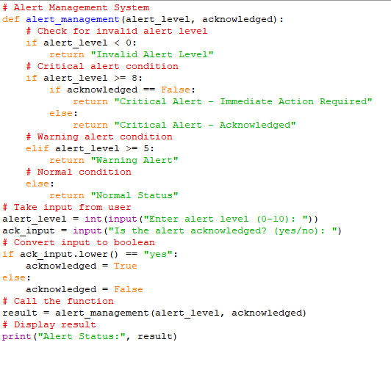
Control flow diagram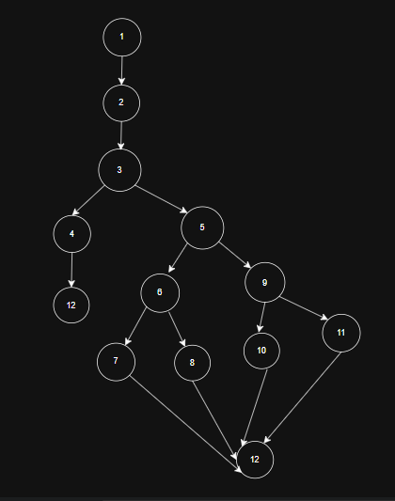
Step 4:Cyclomatic complexity
Method 1:
Inner region=4
Outer region =1
Total v(G)=4+1
V(G)=5
Method 2 :
V(G)=E-N+2
E=Edges=15
N=Nodes=12
V(G)=15-12+2=5
Method 3:
Node 3,5,6,9
V(G)=P+1=4+1=5
Path No | Independent Path | Description
P1 | 1,2,3,4,12 | Alert Level invalid(<0)
P2 | 1,2,3,5,6,7,12 | Critical alert and not acKnowledge
P3 | 1,2,3,5,6,8,12 | Critical alert and acknowledged
P4 | 1,2,3,5,9,10,12 | Warning alert(8<alert level>=5)
P5 | 1,2,3,5,9,11,12 | Normal status(Alert level <5)
Independent paths & test case table
Path No | Independent Path | Test Input | Expected Output
P1 | 1,2,3,4,12 | (-1, False) | Invalid alert level
P2 | 1,2,3,5,6,7,12 | (9, False) | Critical alert
P3 | 1,2,3,5,6,8,12 | (9, True) | Critical alert
P4 | 1,2,3,5,9,10,12 | (6, False) | Warning alert
P5 | 1,2,3,5,9,11,12 | (3,false) | Normal status
Unit test :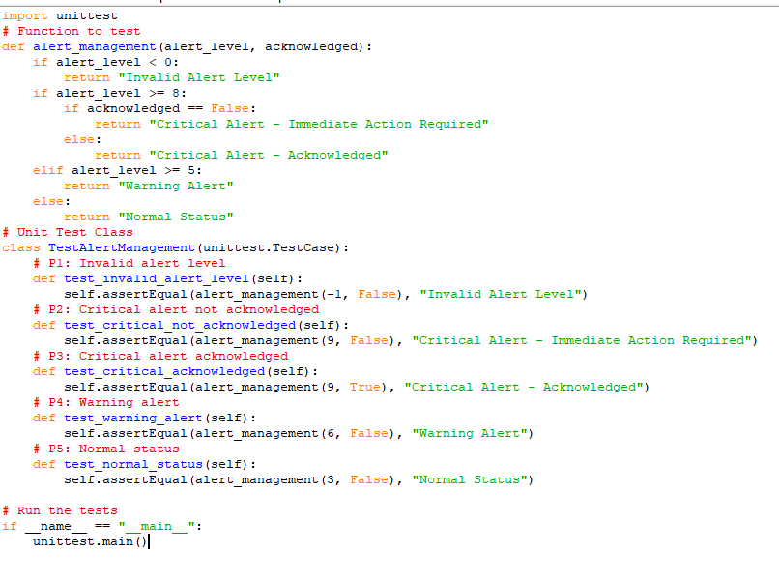

Ran 5 tests in 0.012s
OK
Black Box testing

Step 1: Functional Requirements (From Problem Statement)
The alert_management() module should work according to the following rules:
- Alert level must not be negative.
- If alert_level< 0 → return "Invalid Alert Level"
- If alert_level ≥ 8 and acknowledged = False → return "Critical Alert - Immediate Action Required"
- If alert_level ≥ 8 and acknowledged = True → return "Critical Alert - Acknowledged"
- If alert_level ≥ 5 and < 8 → return "Warning Alert"
- If alert_level< 5 → return "Normal Status"
Step 2: Apply Black Box Testing Techniques
1.Equivalence Partition
2.Boundary Value Analysis (BVA)
1.Equivalence Partition
Alert Level Input Classes
Class | Range | Valid/invalid
Ec1 | <0 | Invalid
Ec2 | 0-4 | Valid
Ec3 | 5-7 | Valid
Ec4 | >=8 | valid

Acknowledge input classes
class | input | Meaning
Ec5 | True | Alert Acknowledge
Ec6 | false | Alert not Acknowledge

Step 3:EquivalencePartiotion Test Cases
Test Case | Input | Expected Output
Ep1 | (-2,False) | Invalid Alert Level
Ep2 | (3,False) | Normal status
Ep3 | (6,false) | Warning Alert
Ep4 | (9,false) | Critical Alert
Ep5 | (9,true) | Critical Alert
Step 4 :Boundary Value Analysis(BVA)
- Important boundaries :
- 0(invalid to valid transition)
- 5(normal to warning)
- 8(warning to critical)
Step5: Boundary test cases
- Boundary at 0
Test No | Test Input | Expected Output | Technique
Bb1 | (-1,false) | Invalid alert Level | Below Boundary
BB2 | (0,False) | Normal status | Boundary value
BB3 | (1,False) | Normal status | Above boundary

- Boundary at 5
Test No | Test Input | Expected Output | Technique
BB4 | (4,false) | Normal status | 5-1
BB5 | (5,false) | Warning alert | Boundary
BB6 | (6,false) | Warning alert | 5+1
- Boundary at 8
Test No | Test Input | Expected Output | Technique
BB7 | (7,false) | Warning alert | 8-1
BB8 | (8,false) | Critical Alert-immediate Action Required | Boundary
BB9 | (9,true) | Critical Alert- Acknowledge | 8+1
3) Black-box testing does NOT end with creating tables
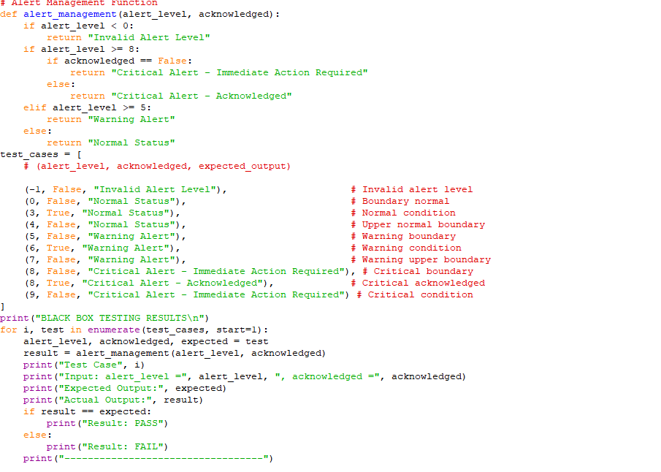
Output :
BLACK BOX TESTING RESULT
Test Case 1
Input: alert_level = -1 , acknowledged = False
Expected Output: Invalid Alert Level
Actual Output: Invalid Alert Level
Result: PASS
----------------------------------
Test Case 2
Input: alert_level = 0 , acknowledged = False
Expected Output: Normal Status
Actual Output: Normal Status
Result: PASS
----------------------------------
Test Case 3
Input: alert_level = 3 , acknowledged = True
Expected Output: Normal Status
Actual Output: Normal Status
Result: PASS
----------------------------------
Test Case 4
Input: alert_level = 4 , acknowledged = False
Expected Output: Normal Status
Actual Output: Normal Status
Result: PASS
----------------------------------
Test Case 5
Input: alert_level = 5 , acknowledged = False
Expected Output: Warning Alert
Actual Output: Warning Alert
Result: PASS
----------------------------------
Test Case 6
Input: alert_level = 6 , acknowledged = True
Expected Output: Warning Alert
Actual Output: Warning Alert
Result: PASS
----------------------------------

Test Case 7
Input: alert_level = 7 , acknowledged = False
Expected Output: Warning Alert
Actual Output: Warning Alert
Result: PASS
----------------------------------
Test Case 8
Input: alert_level = 8 , acknowledged = False
Expected Output: Critical Alert - Immediate Action Required
Actual Output: Critical Alert - Immediate Action Required
Result: PASS
----------------------------------
Test Case 9
Input: alert_level = 8 , acknowledged = True
Expected Output: Critical Alert - Acknowledged
Actual Output: Critical Alert - Acknowledged
Result: PASS
----------------------------------
Test Case 10
Input: alert_level = 9 , acknowledged = False
Expected Output: Critical Alert - Immediate Action Required
Actual Output: Critical Alert - Immediate Action Required
Result: PASS

7.Conclusion
The suspicious activity detection System project was designed to identify unusal or risky user activities in a system.The main goal of this project is to monitor login behaviour and detect suspicious patterns such as too many login attempts,repeated failed logins,or login from unusallocations.This helps improve system and prevent possible misuse or unauthorized access.
During the development of this project ,different software engineering concepts such as requirement analysis,systemdesign,and testing were applied. Diagrams like useCasediagrams,classdiagrams,sequence design,and data low diagram were used to understand and represent the system structure and process clearly.
Testing methods such as Black-Box testing and white box testing were also performed to verify the correctness of the system.Cyclomatic complexity and independent paths were analysed to ensure that different program different program paths are tested properly. The results show that the system works correctly for various input conditions.
Overall, this project helped in understanding how suspicious activities can be detected in a system and how software testing tecniques can be used to ensure reliability and correctness.in the future, system can be improved by adding advanced features such as real-time monitoring machine learning based detection, and integration with larger security Systems.
References
1.Pressman,RogerS.Software Engineering : A practitioner’s Approach,McGraw –Hill Education.
2.python Software foundation.(2024).Python Documentation .Available at: https://docs.python.org
3.GeeksforGeeks : Software Testing Concepts-Black Box and White Box testing available at : https://www.geeksforgeeks.org
4.IEEE Digital Library resources.
5.Ian sommerville,softwareengineering:A practitioners approach,McGraw-Hill Education.
6.draw.io(diagrams.net).Online Diagram Tool for UML and DFD diagrams. Available at : https://app.diagrams.net

Acknowledgement
I would like to express my sincere thanks to our faculty for giving me the opportunity to work on the project titled“suspicious Activity Detection System”.This project helped me understand various concepts of software engineering,System design,and software testing.
I would also like to thank our course instructor for their guidance,support,and valuable suggestions throughout the development of this project .their encouragement helped me complete the work successfully.
Finally,I would like to thank my friends and classmates who supported me by sharing ideas and helping me understand different topics related to the project,their cooperation made it easier to complete this work.
This project helped me improve my knowledge about software design,testing methods,and system develop.
Design
Architecture
Of the
System

- Component Level Design Elements
The component diagram represents the internal architecture of the suspicious activity detection system.the system consists of components such as user interface,authenticationmodule,login monitoring module,suspicious activity detection module,alert management module,database ,and admin dashboard.these components communicate through ports and interfaces.the user interacts with the system through the user interface,and the system monitors login behaviour,detects suspicious activities,stores data in the database,and sends alerts to the admin dashboard.

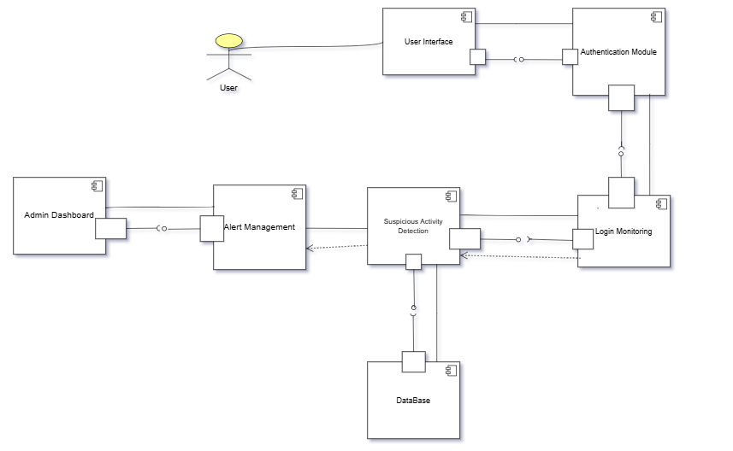
- Deployment Level Design Diagram
The deployment diagram represents the physical environment in which the suspicious Activity Detection System operates.the system consists of different hardware nodes such as the user device,applicationserver,databaseserver,and admin device.the software components including authentication module,login monitoring module,suspicious activity detection module,and alert management module run on the application server.the database server stores user activity logs and system data.communication between devices occurs through network connections.allowing the system to monitor user activities and notify the administrator when suspicious behaviour is detected.
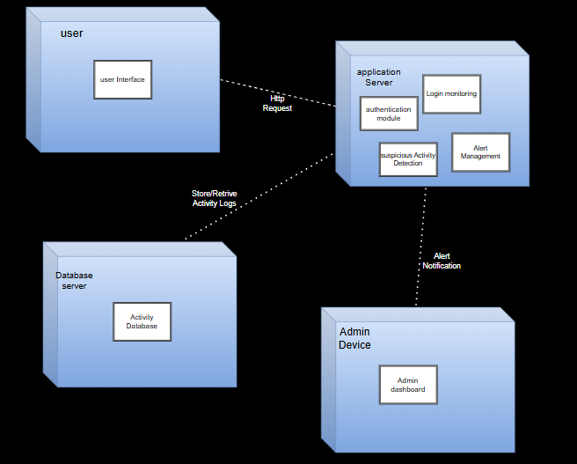

Product
Metrices

Introduction :
Product metrices are used to measures the size,complexity,and quality of the suspicious activity detection system.the metrices help in estimating the effort,time,cost,and the number of defects in the system.
Functional point Analysis(FPA) is used in this project to evaluate the functional size of the system based on user interactions and system characteristics.
The calculation based on user interactions and system characteristics:
- Identification of information domain value
- Calculation of unadjusted functoion points(UFP)
- Calculation of complexity adjustment factor(CAF)
- Calculation of Functional points(FP)
Identification of Information Domain Values
The following values are identified based on the system modules:
- External Inputs(EI):
- User Registration
- User Login
- Upload suspicious Activity data
- Report Suspicious Activity
- Update User profile
- Feedback/compliant Submission
Total external Inputs(EI)=6
- External Outputs(EO) :
- Suspicious Activity Alerts
- Generated Reports
- Notification Message
- Activity Analysis Results
- Admin Dashboard Display
Total External Output(EO)=5
- External Inquiries(EQ):
- View Activity Details
- Search activity records
- Check alert status
- View user Activity History
Total external inquiries(EQ)=4
- Internal Logical Files(ILF):
- User database
- Activity Records Database
- Alert logs
- Detection Results
- System Logs
Total Internal Logical Files(ILF)=5
- External Interface Files(EIF):
- Email Notification System
- External Monitoring System
- Third-Party Data Source
Total External Interface Files(EIF)=3
Calculation of Unadjusted Functional Points(UFP) :
The unadjusted functional points(UFP) are calculated by multiplying the count of each information domain value with its corresponding weighting factor(based on complexity level such as simple,Average,Complex).
Information Domain Value | Count | Simple | Average | Complex | complexity | weight | Total
External inputs(EIs) | 6 | 3 | 4 | 6 | Average | 4 | 6 * 4 =24
External Outputs(Eos) | 5 | 4 | 5 | 7 | Average | 5 | 5*5=25
External inquiries(ILFs) | 4 | 3 | 4 | 6 | Simple | 3 | 4 * 3=12
Internal Logical Files(ILFs) | 5 | 7 | 10 | 15 | Complex | 15 | 5 * 15=75
External Interface files(EIFs) | 3 | 5 | 7 | 10 | Average | 7 | 3 * 7=21
Total |  |  |  |  |  |  | 157
Complexity Adjustment Factor(CAF) :
The complexity Adjustment factor is calculated using 14 general System Characteristics.
Each factor is rated on a scale from 0 to 5 :
- 0→ No influence
- 1 → incidental
- 2 → Moderate
- 3 → Average
- 4 → significant
- 5 → Essential
CAF(Value Adjustment Factor) Table :
Serial Number | Adjustment Factors | Rating
 | Does the system require reliable backup and recovery? | 3
 | Are specialized data communications required to transfer information to or from the application? | 3
 | Are there distributed processing functions? | 2
 | Is performance critical? | 4
 | Will the system run in an existing, heavily utilized operational environment? | 3
 | Does the system require online data entry? | 4
 | Does the online data entry require the input transaction to be built over multiple screens or operations? | 3
 | Are the ILFs updated online? | 4
 | Are the inputs, outputs, files, or inquiries complex? | 3
 | Is the internal processing complex? | 4
 | Is the code designed to be reusable? | 3
 | Are conversion and installation included in the design? | 2
 | Is the system designed for multiple installations in different organizations? | 2
 | Is the application designed to facilitate change and ease of use by the user? | 4
Calculation of ΣFi :
ΣFi= 3 + 3+ 2+ 4 + 3 + 4 + 3 + 4 + 3 + 4 + 3 + 2 + 2 + 4 =44
CAF Calculation :
CAF =0.65 +(0.01 * ΣFi)
= 0.65 + (0.01 * 44)
=0.65 + 0.44 =1.09
Functional Point(FP) :
functional points are calculated by multiplying the unadjusted functional points(UFP) with the complexity adjustment factor(CAF).
Formula : FP =UFP * CAF
FP = 157 * 1.09
Fp= 171.3
FP ~ 171
Cost Estimation :
1.Developer Cost
The developer cost is calculated based on the total effort required to develop the system.
From the functional point analysis :
- Functional point(FP)=171
- 1FP ~ 10 hours
Total Effort = 171 * 10 =1710 hours
Assume :
Cost per hour = Rs.1000
Developer Cost = 170 * 1000 =Rs.17,10,000
The estimated developer cost for the suspicious Activity Detection System is Rs.17,10,000
2.Total Project Cost
The total project cost includes development cost and additional cost such as testing,maintenance and deployment.
Assume :
Additional Cost = 20% of development cost
Additional Cost = 20% * 1710000 = Rs. 3,42,000
Total Project Cost = 1710000 + 3,42,000 = Rs.20,52,000
The total estimated project cost,including development and additional expenses,is Rs.20,52,000.

Emperical
Estimation -
COCOMO Model

- EmpericalEstimation :
Emperical estimation is a technique used in software engineering to estimate effort,time,and cost based on historical data and past project experiences.it relies on real-world observations and previously completed projects rather than theoretical calculations.
Empirical estimation methods use mathematical models derived from historical project data to predict the required resources for a new software project.
Emperical estimation model :COCOMO Model
- COCOMO MODEL :
The basic COCOMO(Constructive Cost Model) is an empirical estimation model used for Quick and approximate calculation of software development effort,time ,and cost .it is based on the size of the software, which is measured in terms of KLOC(Kilo Lines of code).
- Basic cocomo model
The basic COCOMO is an empirical estimation model used to calculate the effort required for software development based on the size of the project in terms of KLOC(kilo Lines of code).it helps in estimating effort,developmenttime,and cost.

Project Mode :
The project “Suspicious Activity Detection System” is categorized under Semi-Detached Mode because it involves medium complexity,a combination of simple and complex modules,and moderate team experiences.
Software Project | A | B | C | D
Organic | 2.4 | 1.05 | 2.5 | 0.38
Semi Detached | 3.0 | 1.12 | 2.5 | 0.35
Embedded | 3.6 | 1.20 | 2.5 | 0.32
- Estimated size of project size = 10 KLOC
- Effort Estimatimation :
Effort(E) = A * (KLOC)^B
For semi-Detached Mode :
A = 3.0
B = 1.12
E = 3.0 *(10)^1.12
E = 3.0 * 13.18
E = 39.54 Person-Months
The estimated effort required to develop the system is approximately 40 Person-Months.
- Development Time Estimation :
Time (T) : C * (Effort)^D
For Semi-Detached :
C = 2.5
D = 0.35
T = 2.5 * (39.54)^0.35
T = 2.5 *3.62
T = 9.05 Months
The estimated development time is 9 Months.
- Intermediate COCOMO Model :
The intermediate COCOMO Model is an extension of the basic cocomomodel . it estimates the effort required for software development by considering not only the size of the project(KLOC) but also various cost drivers that affect productivity.these cost drivers are grouped into product,hardware, personnel , and project attributes.
The factors are known as Cost Drivers and the Intermediate model utilizes 15 such drivers for cost estimation.
(i) Product attributes:
1. Required software reliability extent
2. Size of the application database
3. The complexity of the product
(ii) Hardware attributes:
4. Run-time performance constraints
5. Memory constraints
6. The volatility of the virtual machine environment
7. Required turnabout time
(iii) Personnel attributes:
8. Analyst capability
9. Software engineering capability
10. Applications experience
11. Virtual machine experience
12. Programming language experience
(iv) Project attributes:
13. Use of software tools
14. Application of software engineering methods
15 . Required development schedule
- Effort Adjustment Factor (EAF) :
S.No | Cost Drivers | Ratings | Multiplier
1 | Required Software Reliability | High | 1.15
2 | Database Size | Nominal | 1.00
3 | Product Complexity | Nominal | 1.00
4 | Execution Time Constraint | Nominal | 1.00
5 | Memory Constraint | Nominal | 1.00
6 | Virtual Machine Volatility | Nominal | 1.00
7 | Required turnabout time | Nominal | 1.00
8 | Analyst Capability | High | 1.00
9 | Programmer Capability | Nominal | 1.00
10 | Application Experience | Low | 1.13
11 | Virtual Machine Experience | Nominal | 1.00
12 | Programming Language Experience | Nominal | 1.00
13 | Software Tools | Nominal | 1.00
14 | Software Methods | Nominal | 1.00
15 | Development Schedule | Nominal | 1.00
EAF = 1.15 * 0.86 * 1.13
EAF = 1.12
- Effort Calculation
Formula :
E = (A *(KLOC) ^B ) * EAF67621``
E = (3.0 * (10)^1.12)*1.12
E = 3.0 * 13.18*1.12 = 44.28 Person-Months
2.Development Time Calculation
Formula
Time = C * (Effort)^D
T = 2.5 * (44.28) ^0.35
T = 9.45 Months
3.Persons Required
Persons = Effort / Time
Persons = 44.28/9.45
Persons = 4.68
Persons Required 5 Members.

